Ackton Pastures Primary Academy
RE Progression Grid
The progression grid outlines the specific knowledge which pupils are expected to learn in each phase, over a two year cycle, along with the specific vocabulary which supports this understanding.
Why people are special in religions and how this influences how people worship today.
Skills | At Key Stage One:  Explore and understand the teachings of Islam and how they worship.  Explore and understand the teachings of Judaism and how they worship. | At Lower Key Stage Two:  Explore why Jesus is important to some people.  Examine the teachings of different religions regarding what is right and wrong. | At Upper Key Stage Two:  Examine the teachings of Jesus and wether these teachings can be applied to life today.  Explore the key messages of Christians and Humanists and compare.
Significance of sacred places
Skills | At Key Stage One:  Examine what makes places sacred. | At Lower Key Stage Two:  Understand why and where people pray with a focus on Islam, Hinduism and Christianity to compare. | At Upper Key Stage Two:  Focus on sacred places in all religions covered and ebate the question ‘If God is everywhere, why go to a place of worship?’.
Special times of year and how different religions choose to celebrate
Skills | At Key Stage One:  Examine how and why we celebrate sacred times of the year in Christianity, Islam and Judaism. | At Lower Key Stage Two:  Understand why festivals are important in religion with a focus on all religions previously covered.  Understand what is meant by life as a journey for different religions and compare similarities and differences. | At Upper Key Stage Two:  Explore how different religions can express their beliefs through the arts.
Faith communities and what it means for different religions in Britain today
Skills | At Key Stage One:  Explore what it means to be part of a faith community. | At Lower Key Stage Two:  Examine what it means to be a Christian in Britain today with reference to other religions for comparison.  Examine what it means to be a Hindu in Britain today. | At Upper Key Stage Two:  Examine what it means to be a Muslim in Britain today.
Sacred texts and what they can teach us about living a good life
Skills | At Key Stage One:  Combine knowledge of Christianity, Judaism and Islam to examine sacred books.  Explore how religions view the world (focus on Christianity and Judaism but other religons can be used where appropriate) and understand why it is important to care for the world. | At Lower Key Stage Two:  Understand why the Bible is important to Christians through analysing stories in the Bible. | At Upper Key Stage Two:  Explore how religions such as Islam, Christianity, Hindus and Humanists (non-religious views) respond when life gets difficult.  Examine different religious views of how we should care for eachother (Chrsitianity, Hinduism and Islam).

Overarching ‘Tier 2’ RE Vocabulary
Topic Vocabulary | At Key Stage One: | At Lower Key Stage Two:  ALL WORDS AT KS1 and: | At Upper Key Stage Two:  ALL WORDS AT KS1, LKS2 and:

Cycle One – Autumn Term
 | Key Stage One |  | Lower Key Stage Two |  | Upper Key Stage Two
 | Autumn 1- 1.1: Who is a Christian and what do they believe?  Autumn 2- 1.6: How and why do we celebrate special and sacred times? (Christianity with links to Christmas) |  | Autumn 1- L2.1: What do different people believe about God?  Autumn 2- L2.7: What does it mean to be a Christian in Britain today? - Link to Christmas is appropriate. |  | Autumn 1- U2.2 What would Jesus do? Can we live by the values of Jesus in the twenty-first century?  Autumn 2- U2.3 What do religions say to us when life gets hard?
Wider Knowledge | 1.1  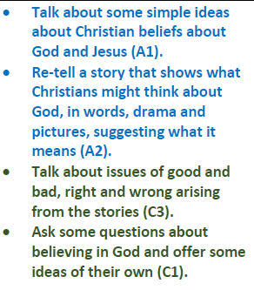  1.6  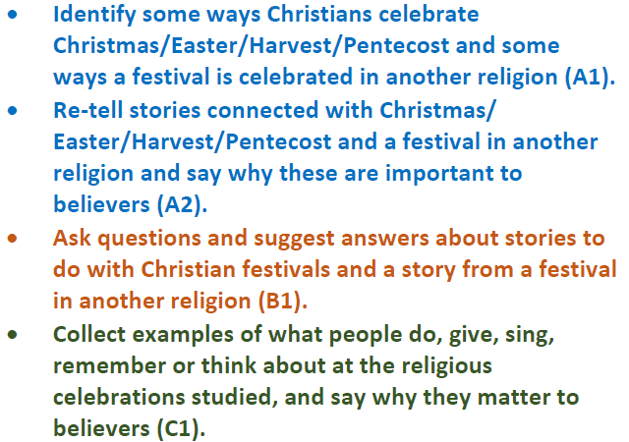 |  | L2.1  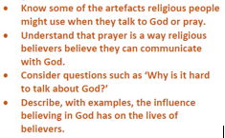  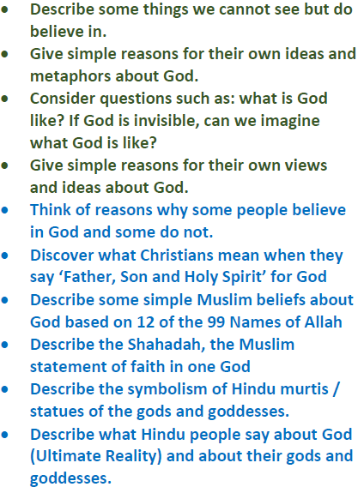  L2.7  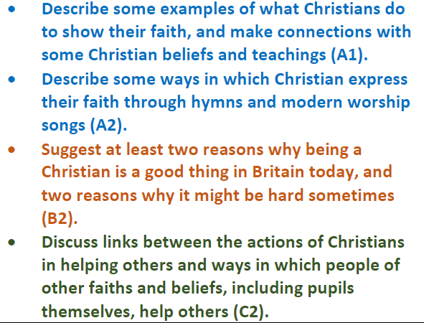 |  | U2.2  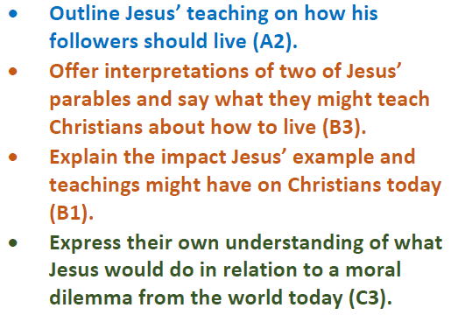  U2.3  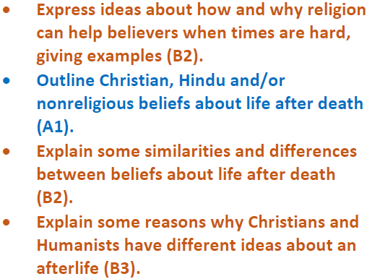
Topic Vocabulary | Tier 2 Vocabulary  1.1  Miracle  Worship  God  Creator  Bible  Christian  Neighbour (as taught in the Bible)  Temptation  1.6  Sacred  Festival  Holy | Tier 3 Vocabulary  1.1  Old Testament  New Testament  Parable  Holy Trinity  1.6  Easter  Good Friday  Palm Sunday  Crucifixion  Disciples | Tier 2 Vocabulary  L2.1  Metaphor  Creator  Preserver  L2.7  Community  Faith  Worship  God | Tier 3 Vocabulary  L2.1  Father  Son  Holy Spirit  Allah  Qur’an  Prophet  Trimurti  L2.7  Muslim  Buddhist  Sikh  Christian  Hymn | Tier 2 Vocabulary  U2.2  Moral dilemma  Mission  U2.3  Afterlife  Judgement | Tier 3 Vocabulary  U2.2  Incarnation  Salvation  Holy Week  Palm Sunday  Ash Wednesday  Maundy Thursday  Good Friday  Reincarnation  Self-sacrificial love  U2.3  Karma  Soul  Moksha  Barzakh

Cycle One – Spring Term
 | Key Stage One |  | Lower Key Stage Two |  | Upper Key Stage Two
 | Spring 1- 1.2: Who is a Muslim and what do they believe?  Spring 2- 1.3: Who Jewish and what do they believe? |  | Spring 1- L2.3: Why is Jesus inspiring to some people?  Spring 2- L2.4: Why do people pray? |  | Spring 1 and 2- U2.7 What matters most to Christians and to Humanists?
Wider Knowledge | 1.2  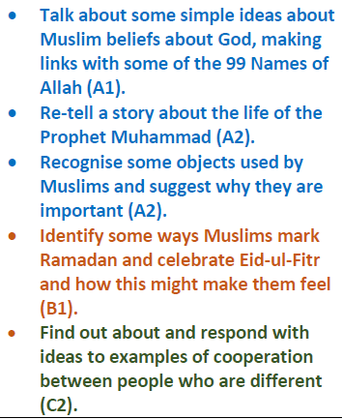  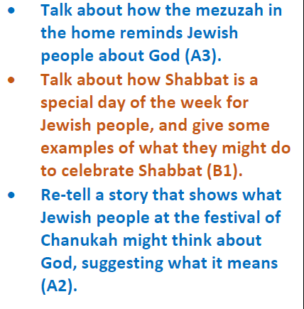  1.3 |  | L2.3  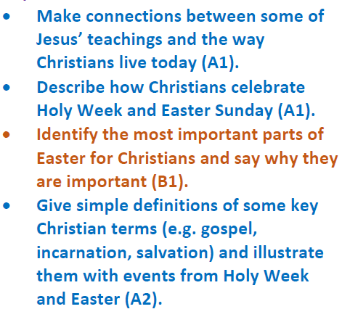  L2.4  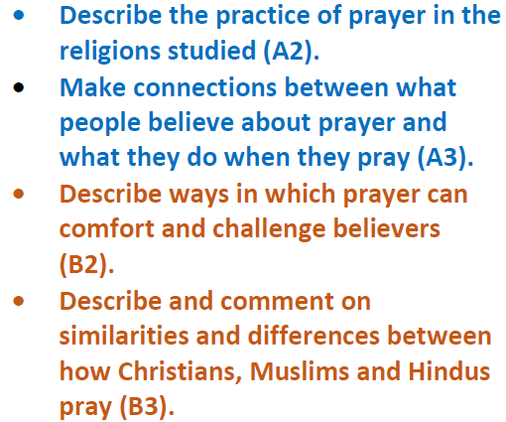 |  | U2.7  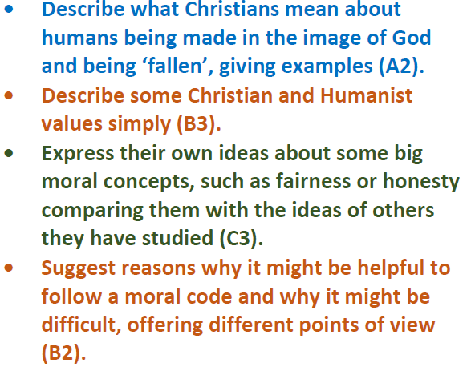
Topic Vocabulary | Tier 2 Vocabulary  1.2  Belief  Faith  Celebrate  Muslim  Islam  1.3  Belief  Faith  Celebrate  Jewish | Tier 3 Vocabulary  1.2  Allah  Eid-ul-Fitr  Ramadan  Qur’an  Prophet  1.3  Shabbat  Chanukah  Shema  Mezuzah  Star of David  Synagogue | Tier 2 Vocabulary  L2.3  Inspirational  Gratitude  Sacrifice  L2.4  Bible  Pray  Confession | Tier 3 Vocabulary  L2.3  ‘The Fall’  Incarnation  Salvation  Holy Week  Palm Sunday  Ash Wednesday  Maundy Thursday  Good Friday  Surah  L2.4  Qur’an  Church  Mosque  Synagogue  Shrine | Tier 2 Vocabulary  Justice  Morals  Tolerance | Tier 3 Vocabulary  Code for living  Humanist  ‘The Fall’  The Ten Commandments

Cycle One – Summer Term
 | Key Stage One |  | Lower Key Stage Two |  | Upper Key Stage Two
 | Summer 1 and 2- 1.5: What makes some places sacred? |  | Summer 1 and 2- L2.6: Why do some people think that life is a journey? What significant experiences mark this? |  | Summer 1 and 2- U2.8 What difference does it make to believe in Ahimsa (harmlessness), Grace (the generosity of God), and Ummah (community)?
Wider Knowledge | 1.5  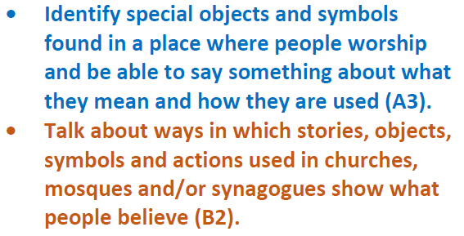 |  | L2.6  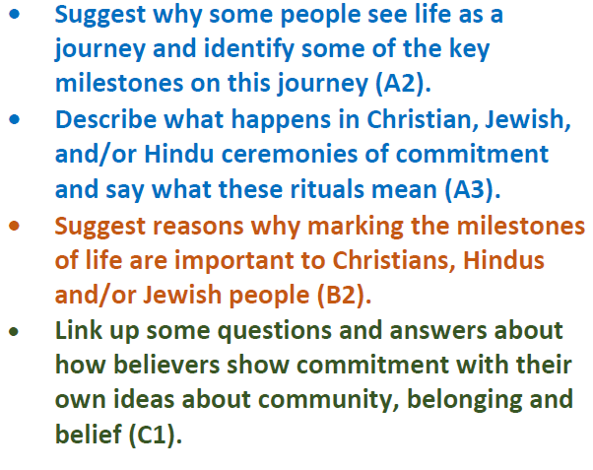 |  | U2.8  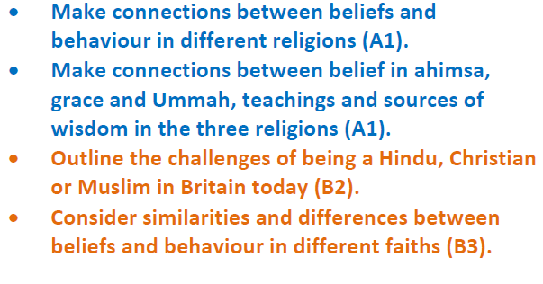
Topic Vocabulary | Tier 2 Vocabulary  Sacred  Holy  Belief  Worship  Pray | Tier 3 Vocabulary  Church  Lectern  Communion  Mosque  Mihrab  Synagogue  Torah | Tier 2 Vocabulary  Ceremony  Commitment  Community  Belief  Milestones | Tier 3 Vocabulary  Bat and Bar Mitzvah  Ritual  Faith Community  Baptism  Purifying  Reincarnation | Tier 2 Vocabulary  Community  Principles  Commitment | Tier 3 Vocabulary  Ahimsa  Sewa  Grace  Ummah  Zakat  Hajj

Cycle Two – Autumn Term
 | Key Stage One |  | Lower Key Stage Two |  | Upper Key Stage Two
 | Autumn 1 and 2- 1.7: What does it mean to belong to a faith community? |  | Autumn 1- L2.2: Why is the Bible important to Christians  Autumn 2- L2.5: Why are festivals important to religious communities? |  | Autumn 1- U2.1: Why do some people believe God exists?  Autumn 2- U2.4: If God is everywhere, why go to a place of worship?
Wider Knowledge | 1.7  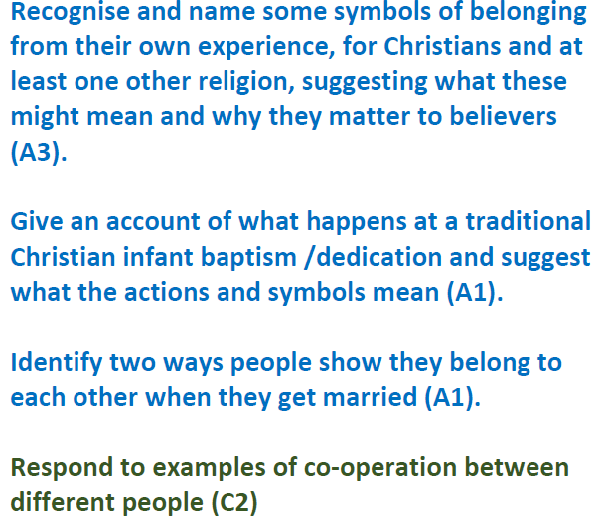 |  | L2.2  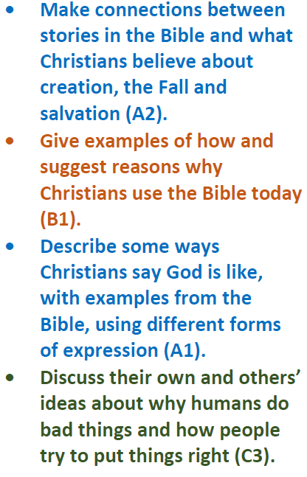  L2.5  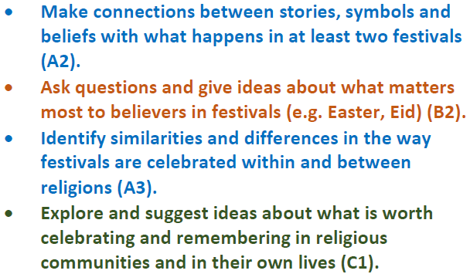 |  | U2.1  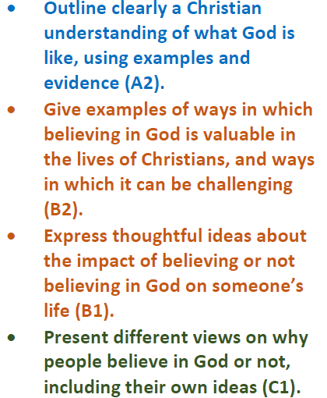  U2.4  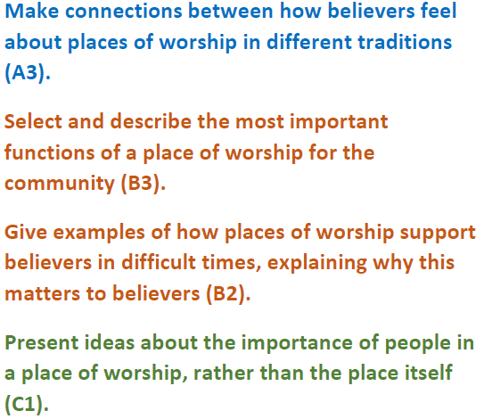
Topic Vocabulary | Tier 2 Vocabulary  Community  Faith  Blessing  Symbolise  Ceremony | Tier 3 Vocabulary  Baptism  Muslim  Muhammad  Ka’aba  Allah  Buddhist  Sikh  Christian  Rosary  Chuppah | Tier 2 Vocabulary  L2.2  Wisdom  Belief  L2.5  Sacred  Festival | Tier 3 Vocabulary  L2.2  Apostles  Guru  Psalm  L2.5  Harvest  Pentecost  Sukkot  Christmas  Diwali  Eid  Pesach  Rosh Hashanah  Yom Kippur | Tier 2 Vocabulary  U2.1  Faith  Fact  Belief  Opinion  Disprove  Virtues  U2.4  Worship  Sacred | Tier 3 Vocabulary  U2.1  Atheist  Agnostic  Theist  Evolution  U2.4  Anglican  Baptist  Mandir  Community  Synagogue  Mosque

Cycle Two – Spring Term
 | Key Stage One |  | Lower Key Stage Two |  | Upper Key Stage Two
 | Spring 1- 1.6: How and why do we celebrate special and sacred times? (Other religions) (Easter, Eid, Ramadan)  Spring 2- 1.4: What can we learn from sacred books? |  | Spring 1 and 2- L2.8: What does it mean to be a Hindu in Britain today? |  | Spring 1 and 2- U2.5: Is it better to express your religion in arts and architecture or in charity and generosity?
Wider Knowledge | 1.6  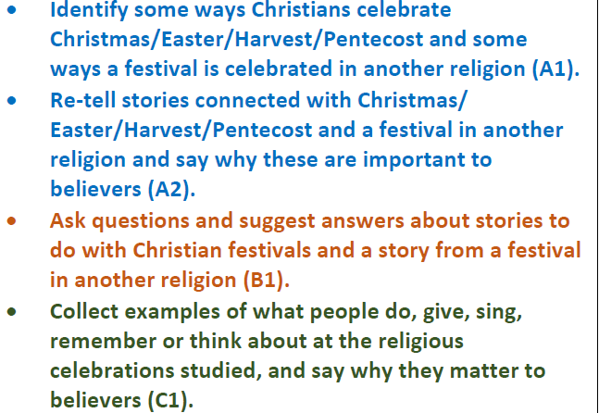  1.4  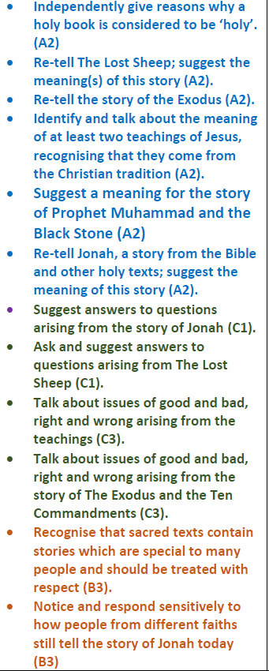 |  | L2.8  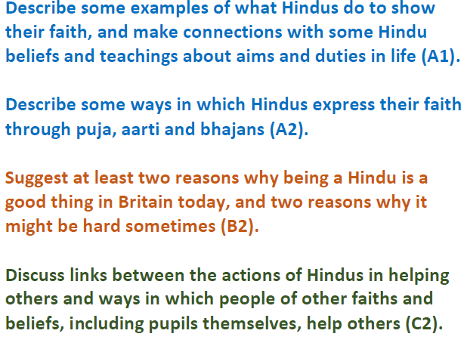 |  | U2.5  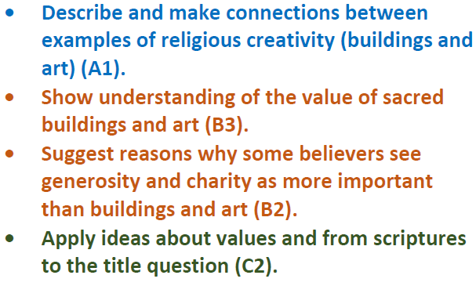
Topic Vocabulary | Tier 2 Vocabulary  1.6  Sacred  Festival  Holy  1.4  Faith  Sacred  Respect | Tier 3 Vocabulary  1.6  Pentecost  Sukkot  Diwali  Eid  Passover (Pesach)  Seder plate  1.4  Bible  Parable  Qur’an  Tenakh  Torah  Moses  Ten Commandments | Tier 2 Vocabulary  Faith  Belief  Duty  Aim | Tier 3 Vocabulary  Ritual  Aarti  Moksha  Karma  Reincarnation | Tier 2 Vocabulary  Belief  Scriptures  Charity  Generosity | Tier 3 Vocabulary  Geometrical art  Representational art  Cathedral  Mosque  Architecture

Cycle Two – Summer Term
 | Key Stage One |  | Lower Key Stage Two |  | Upper Key Stage Two
 | Summer 1 and 2- 1.8: How should we care for others and the world, and why does it matter? |  | Summer 1 and 2- L2.9: What can we learn from religions about deciding what is right and wrong? |  | Summer 1 and 2- U2.6 What does it mean to be a Muslim in Britain today?
Wider Knowledge | 1.8  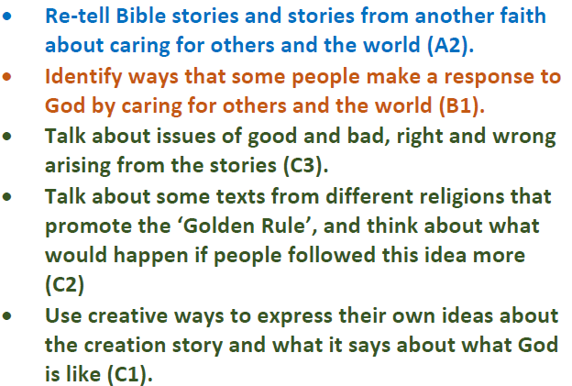 |  | L2.9  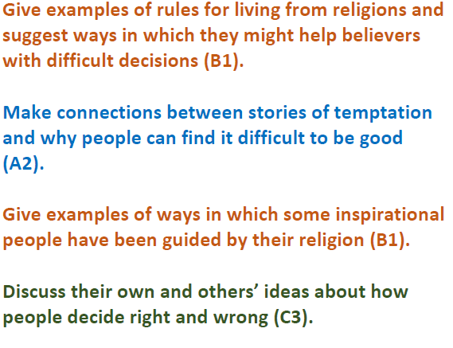 |  | U2.6  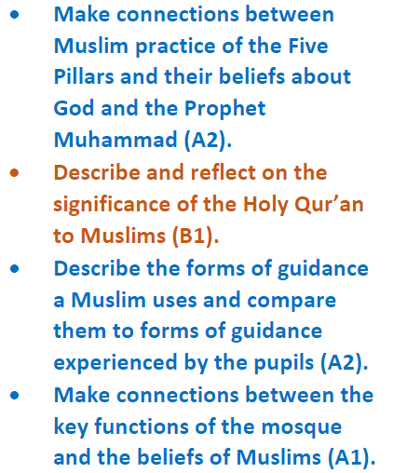
Topic Vocabulary | Tier 2 Vocabulary  Faith  Community  Parable | Tier 3 Vocabulary  ‘Golden rule’  Bible  Genesis  Qur’an  Tenakh  Torah | Tier 2 Vocabulary  Parable  Justify  Peacemakers  Conscience  Temptation | Tier 3 Vocabulary  The Golden Rule  The Ten Commandments  Torah  Beatitudes  Humanist | Tier 2 Vocabulary  Prophet  Holy  Belief | Tier 3 Vocabulary  Five Pillars of Islam  Ibadah (worship and belief in action).  Shahadah (belief in one God and his Prophet)  Salat (daily prayer)  Sawm (fasting)  Zakat (alms giving)  Hajj (pilgrimage)  Qur’an

