Ackton Pastures Primary Academy
Art and Design Progression Grid
Drawing skills underpin all of our artistic learning, and pupils explore and develop their drawing skills as part of their research and understanding of the artists and knolwedge for each unit of work. Each academic year, students will study the works of three famous artists in the areas of Painting and Printing, 3D Design – Sculpture and Textiles and Collage. At the beginning of each unit of work, pupils will study an artist, their work, style, skills and lives, before using those techniques to explore work more widely.

Throughout the Art and Design learning, pupils will:
A1 Study the work of a range of great artists, craft makers and designers and understand the historical and cultural development of their art forms.
A2 Evaluate and analyse creative works using the language of art, craft and design.

 | At Key Stage One:  E1 record and explore ideas from first hand observations.  E2 ask and answer questions about starting points for their work.  E3 develop and share their ideas, try things out and make changes.  E4 describe the differences and similarities between different practices and disciplines, and making links to their own work.  E5 think critically about their art and design work. | At Lower Key Stage Two:  E1 create sketch books to record their observations and use them to review and revisit ideas.  E2 record and explore ideas from first hand observations, experience and imagination and ideas for different purposes.  E3 question and make thoughtful observations about starting points and select ideas for use in their work, recording and annotating in sketchbooks.  E4 think critically about their art and design work. | At Upper Key Stage Two:  E1 create sketch books to record their observations and use to review and revisit ideas.  E2 record and explore ideas from first hand observations, experience and imagination and ideas for different purposes.  E3 question and make thoughtful observations about starting points and select ideas for use in their work, recording and annotating in sketchbooks.  E4 think critically about their art and design work.
 | Overarching Tier 2 Vocabulary
 | Art Tier 2 Vocabulary @ KS1: | Art Tier 2 Vocabulary @ LKS2: | Art Tier 2 Vocabulary @ UKS2:
 | observation  difference  similarity  tint  tone  primary colour  secondary colour  thick  thin  line  shape  colour  mix  texture | All KS1 vocabulary plus:  media  hue  contrast  spectrum  transparent  opaque  portrait  landscape  evaluate  foreground  background  technique  scale  symmetry  refine  colour scheme | All previous vocabulary plus:  distance  symbolic  subtle  complex  complementary  contrasting  atmosphere  representation

The following progression grids outline the skills and vocabulary to be taught across each phase, along with a sequence of artists pupils will study in each phase. There are two artists, one for each stage of the cycle for drawing and painting/printing and one for each of sculpture and collage which alternate each year of the cycle. Pupils are expected to learn:
- Their name
- Date of birth
- The time period in which they lived
- The reasons their art is being studied
- Their styles, their techniques and the subjects of their work
- Important elements of their biographies which influenced their works

Drawing
 | Key Stage One |  | Lower Key Stage Two |  | Upper Key Stage Two
Knowledge | 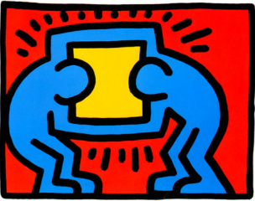  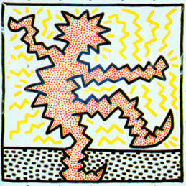  Keith Haring  http://www.haring.com/!/art-work/781#.XdnL2ej7RPY | Pablo Picasso  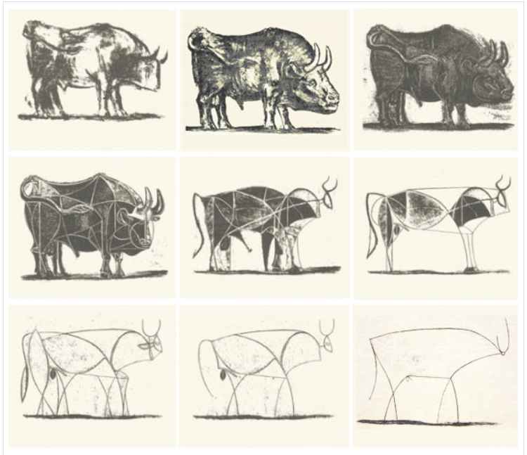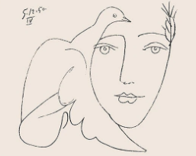 | Louise Bourgeois  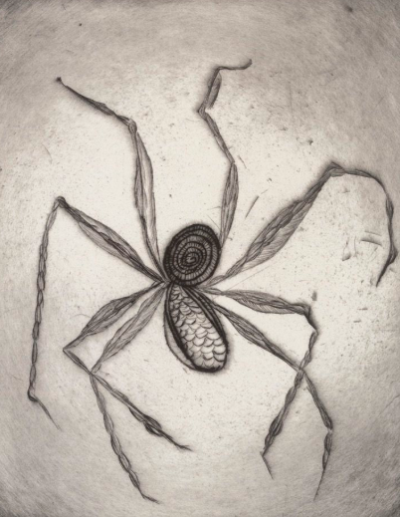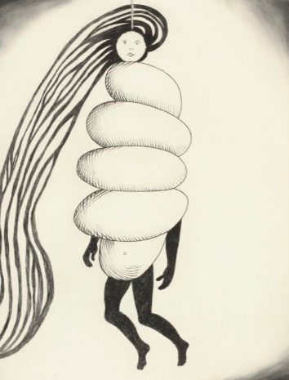 | Leonardo Da Vinci  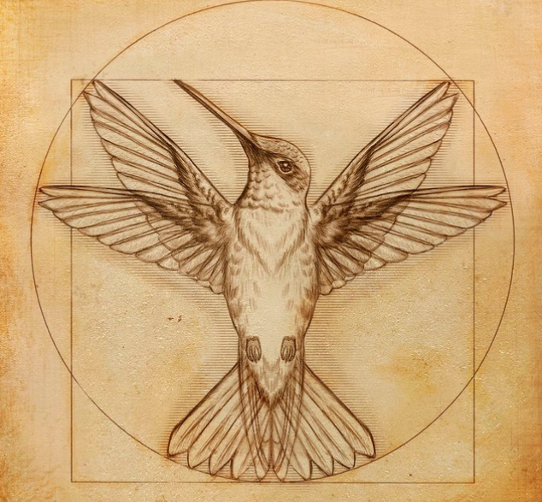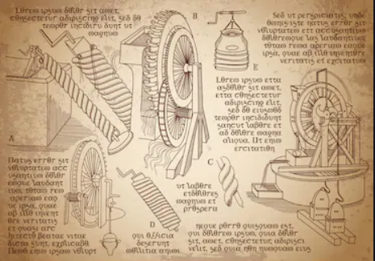 | David Lozeau  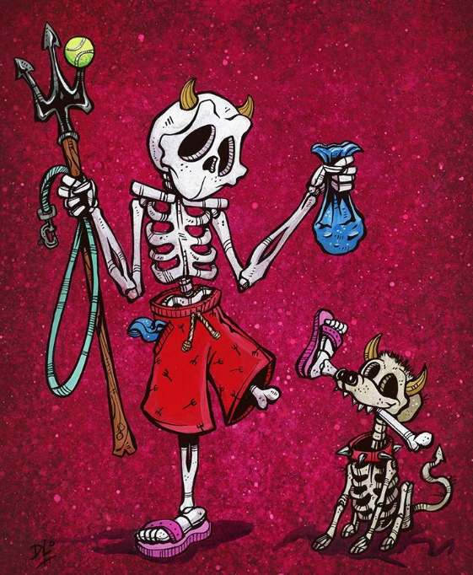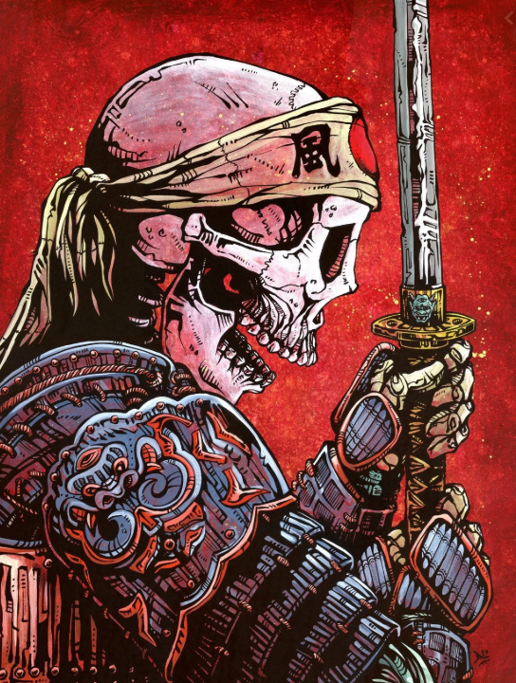 | Ben Kwok  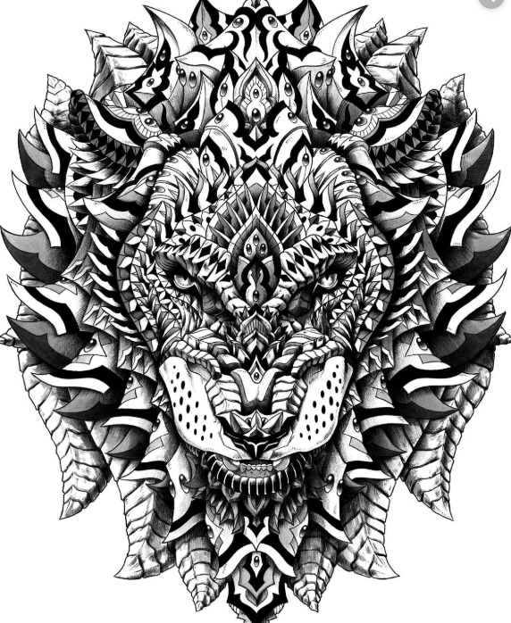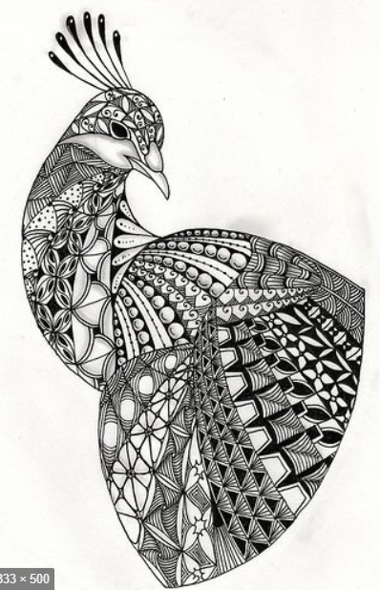
Skills | D1 experiment with and control marks made with different media: pencils, rubbers, crayons, pastels, felt tips, charcoal, ballpoints, chalks.  D2 draw lines and shapes from observations using different surfaces.  D3 invent lines and shapes in drawing.  D4 use tracing, copying and free-drawing skills  D5 investigate tone by drawing light/dark lines, patterns and shapes.  D6 investigate pattern and texture by describing, naming, rubbing and copying. |  | D1 draw for a sustained periods of time.  D2 use a sketchbook to collect and develop ideas from a range of sources  D3 experiment with marks and lines with a wide range of implements e.g. charcoal, chalk, pencil, crayon, pens etc.  D4 experiment with different grades of pencil to achieve varied tone  D5 create texture and pattern in drawing with a range of implements. |  | D1 work on sustained, independent, detailed drawings.  D2 develop close observational skills.  D3 use a sketchbook to collect and develop ideas.  D4 experiment with wet or dry media to make different marks, lines, patterns, textures and shapes within a drawing.  D5 use different techniques for different purposes i.e. shading, hatching, and blending.  D6 develop drawing using tonal contrast and mixed media.  D7 begin to use simple perspective in their work i.e. by using single focal point on horizon.  D8 begin to develop an awareness of composition, scale and proportion i.e. foreground, middle ground, background.
Vocabulary | Tier 2:  observation  colour  thick  thin  line  shape | Tier 3:  shade  smudge  sketch | Tier 2:  scale  symmetry  refine  hue  tint  tone | Tier 3:  grades of pencil  blend  shade | Tier 2:  distance  subtle  complementary  contrasting  atmosphere  representation | Tier 3:  grades of pencil  blend  shade

Painting and Printing
 | Key Stage One |  | Lower Key Stage Two |  | Upper Key Stage Two
Knowledge | P: Wassily Kandinsky  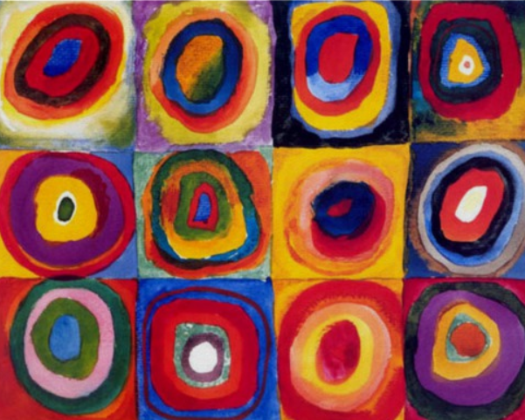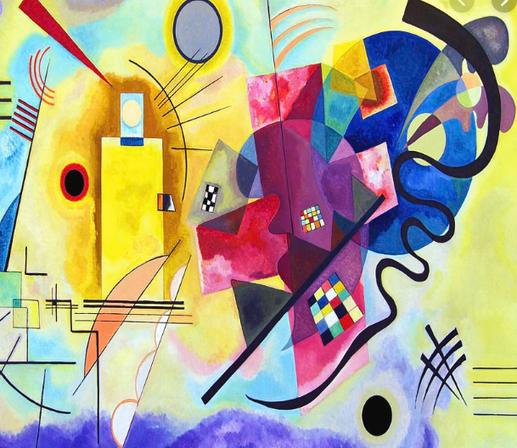 | PR: Cornelius Krieghoff (Insp.)  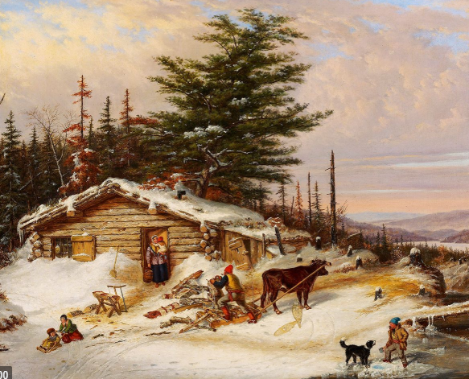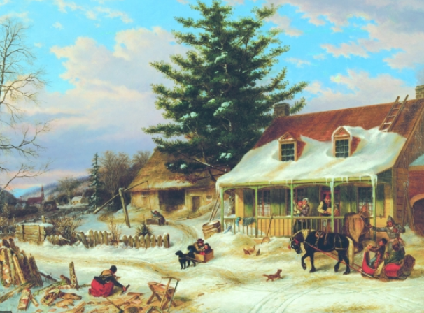 | P: Pablo Picasso  P: Hokusai  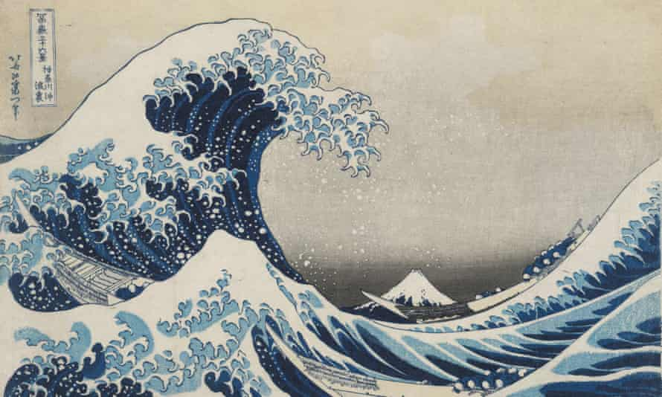 | Pr: Georgia O’Keeffe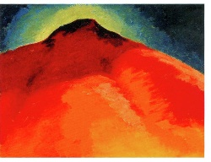  Pr: Andy Warhol  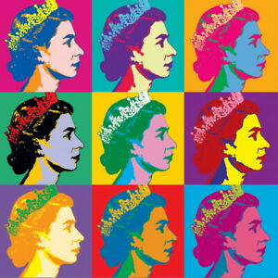 | P: Sophie Knight  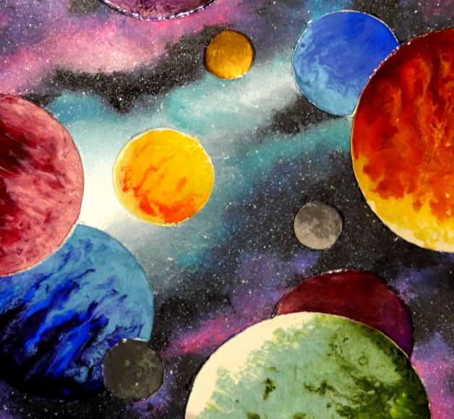  P: Claude Monet  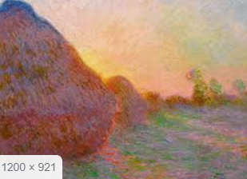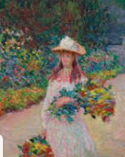 | Pr: India Flint  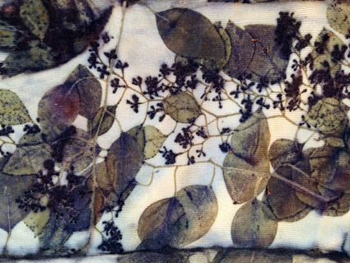  Pr: William Morris 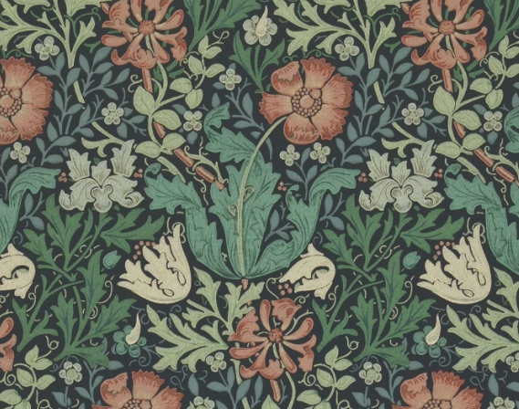
Skills | P1 use a variety of tools and techniques i.e. brush sizes and types.  P2 mix and match colours to artefacts and objects.  P3 work on different scales.  P4 experiment with tools and techniques e.g. layering, mixing.  P5 name and mix primary colours, shades and tones.  P6 create textured paint by adding material, i.e. sand or plaster  PR1 print with a range of hard and soft materials e.g. corks, sponge, fruit and vegetables.  PR2 take simple prints i.e. mono-printing.  PR3 design and build repeating patterns and recognise pattern in the environment.  PR4 create simple printing blocks for press print.  PR5 experiment with overprinting motifs and colour |  | P1 experiment with different effects and textures including blocking in colour, washes, thickened paint creating textural effects, adding depth and distance.  P2 create different effects and textures with paint.  P3 use language of and mix primary and secondary colours and use tints and shades.  PR1 create printing blocks using relief or impressed method.  PR2 develop print techniques i.e. mono-printing, block printing, relief or impressed method.  PR3 create repeating patterns.  PR4 print with two colour overlays. |  | P1 develop a painting from a drawing.  P2 experiment with different media and materials for painting.  P3 create imaginative work from a variety of sources e.g. observational drawing, music, poetry.  P4 mix and match colours to create atmosphere and light effects.  P5 identify, mix and use primary, secondary, complimentary and contrasting colours.  PR1 create printing blocks using sketchbook ideas.  PR2 develop techniques  PR5 experiment with overprinting motifs and colour.
Vocabulary | Tier 2: tools  brush size (thick/thin)  colour  primary/secondary colours  tint  tone  mix | Tier 3:  acrylic / poster / watercolour  mono-printing  dent  printing  gouge  scrape | Tier 2:  colour scheme / blocking  spectrum  shade  tint  tone  hue  foreground  background  landscape  portrait | Tier 3:  relief/impressed method  block printing  properties of paint  wash  warm colours  cold colours | Tier 2:  distance  symbolic  subtle  complex  complementary  contrasting  atmosphere  representation | Tier 3:  Consolidate all previous

3D Design – Sculpture (Once in Cycle A or B)
 | Key Stage One |  | Lower Key Stage Two |  | Upper Key Stage Two
Knowledge | Joan Miro Nikki De Saint Phalle  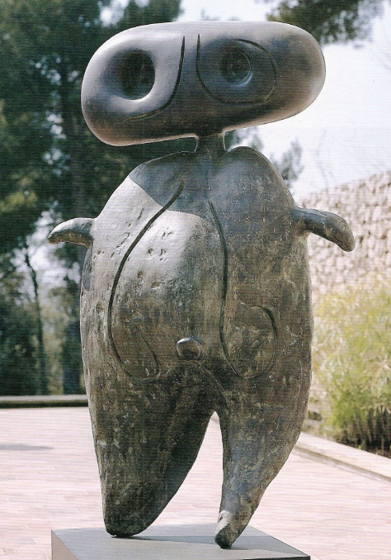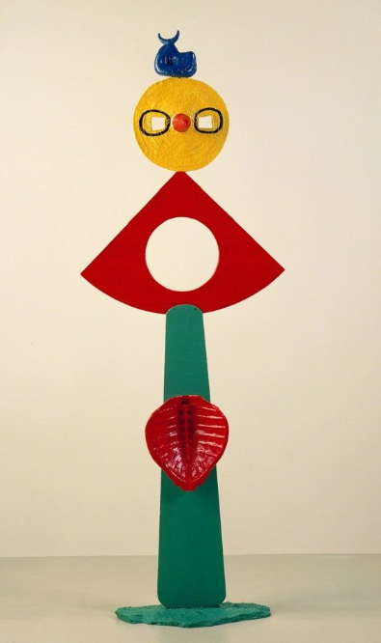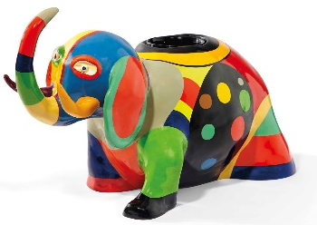 |  | Barbara Hepworth  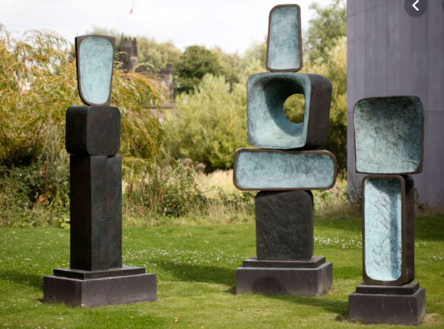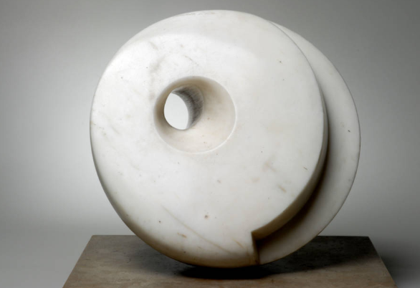 |  | Louise Goodman Joseph Hayton  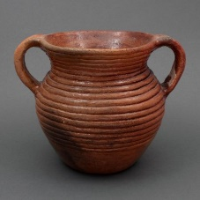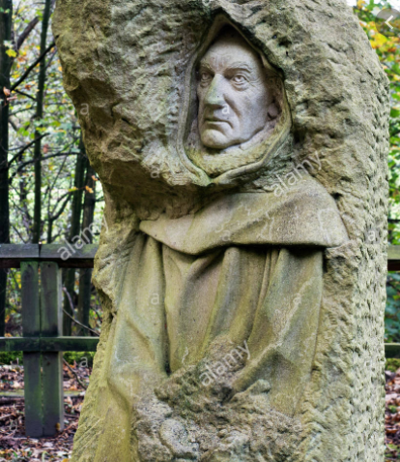
Skills | 3D1 manipulate malleable materials in a variety of ways i.e. rolling, joining and kneading.  3D2 explore sculpture with a range of malleable media.  3D3 work safely with materials and tools.  3D4 experiment with constructing and joining recycled, natural and manmade materials |  | 3D1 plan, design and make models from observation or imagination.  3D2 develop skills in joining, extending and modelling clay.  3D3 use papier mache to create simple 3D effects.  3D4 experiment with constructing and joining recycled, natural and manmade materials.  3D5 create textures and patterns in malleable materials including clay. |  | 3D1 shape, form, model and construct from observation and imagination.  3D2 use recycled, natural and manmade materials to create sculptures.  3D3 plan a sculpture through drawing and other preparatory work.  3D4 develop skills in using clay including slabs, coils, slips etc.  3D5 produce patterns and textures in malleable materials.
Vocabulary | Tier 2:  shape  texture | Tier 3:  join  slip  form  malleable  manipulate  roll  knead  sculpt(ure)  construct | Tier 2:  transparent  opaque  technique  media | Tier 3:  carve  surface | Tier 2:  symbolic  complex  complementary  contrasting  representation | Tier 3:  Consolidate all previous

Textiles and Collage (Once in Cycle A or B)
 | Key Stage One |  | Lower Key Stage Two |  | Upper Key Stage Two
Knowledge | Paul Klee (inspiration for collage) Anni Albers (weaving)  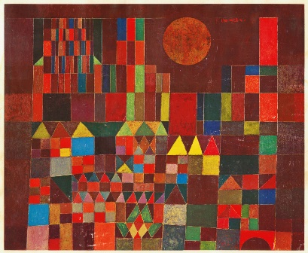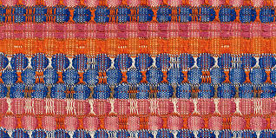 |  | Hannah Hoch – collage Mayan embroidery  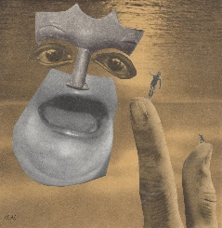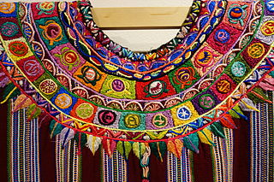 |  | Beatriz Milhazes: Collage  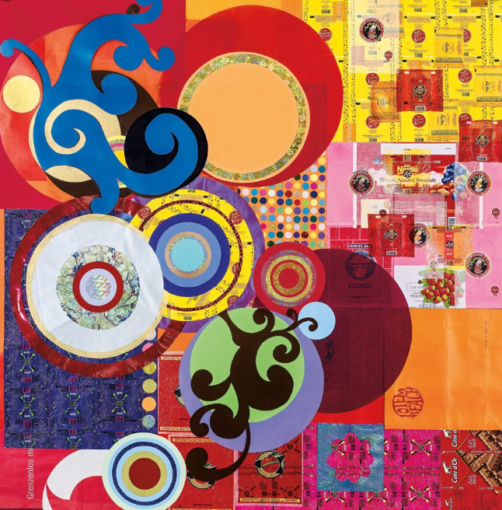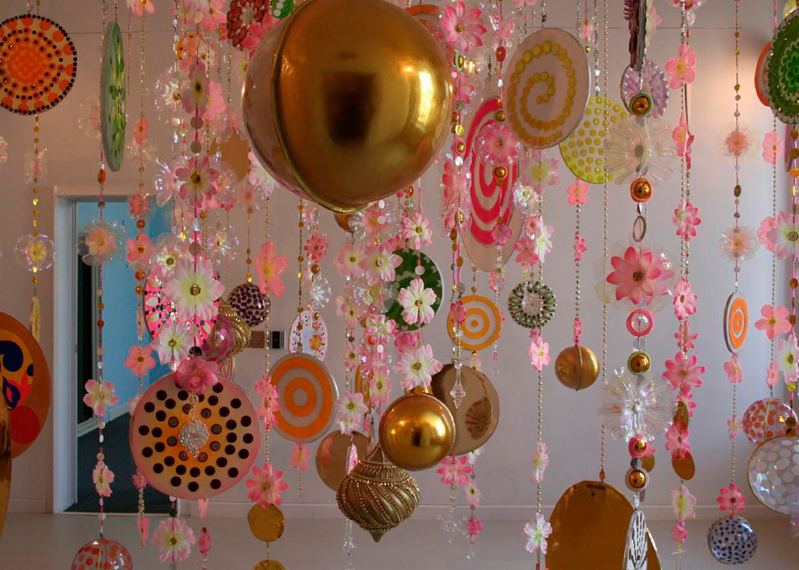
Skills | T1 choose fabrics/threads based on colour, texture and shape.  T2 cut and shape fabric using scissors/snips.  T3 apply shapes with glue or stitching.  T4 apply decoration using beads, buttons, feathers etc.  T5 apply colour with printing, dipping, fabric crayons.  T6 create fabrics by weaving materials, i.e. grass through twigs.  C1 create images from a variety of media e.g. photocopies, fabric, crepe paper, magazines etc.  C2 collect, sort and group materials or different purposes in different ways/shapes, i.e. texture, colour.  C3 arrange and glue materials to different backgrounds.  C4 fold, crumple, tear and overlap papers. |  | T1 use a variety of techniques e.g. printing, dyeing, weaving and stitching to create different textural effects.  T2 develop skills in stitching, cutting and joining  C1 experiment with a range of collage techniques such as tearing, overlapping and layering to create images and represent textures.  C2 use collage as a means of collecting ideas and information and building up a visual vocabulary. |  | T1 use fabrics to create 3D structures.  T2 experiment with a range of media to overlap and layer creating textures, effects and colours.  C1 add collage to a printed or painted background.  C2 use a range of media to create collages.  C3 use different techniques, colours and textures when designing and making pieces of work.  C4 use collage as a means of extending work from initial ideas.
Vocabulary | Tier 2:  shape  texture | Tier 3:  tear  rip  fold  layer  weave | Tier 2:  surface  transparent  opaque  media  colour scheme | Tier 3:  weave  embroider  tapestry | Tier 2:  complementary  contrasting | Tier 3  Consolidate all previous

